Ashley Smith

Southern New Hampshire University

CS 499

4-1 Journal: Career Choice and Artifact Update

**Part One:**

1. Have you changed your career plans? If so, what prompted this change? If not, why have you remained with your original plan?

I originally began my degree wanting to do coding, but realized I did not want to have a desk job sitting at a computer for hours. After being a school computer technician for about a year, I decided I wanted to try teaching. I began teaching 4 years ago with A/V and graphic design to high schoolers. I really enjoyed getting to be creative in work and with my students.

1. How has your thinking about your career evolved?

I still somewhat enjoy coding, but not quite as much as teaching. I originally went from a business degree to education then ended with computer science. I somewhat regret changing from education to computer science, but I do think my current degree has helped me advance in my current career.

My career has evolved in many different ways. For example, I began teaching high schoolers and liked it and wanted to give a try at some younger levels and came to find out that the lower levels were not for me. I am working on completing my degree and graduating this April while also working on my teacher certification.

1. Have you completed any research about your choice of career? How has this impacted your thinking? Have you thought about seeking an advanced degree or certification after earning your undergraduate degree?

I did a little research when I first accepted my first teaching position as a print shop teacher, because I needed to teach all of the TEKS required to be a teacher for print shop. By being a print shop teacher, it taught me a lot of things I needed to know for my Technology Applications teacher certification. I think without having taught those classes previously, I would struggle a little for my certification. The only certification I am planning on getting after completing my bachelors will be my teaching certification in an alternative teaching program.

1. Which course outcomes have you achieved so far, and which ones remain?

I have slowly completed all of my college classes in the past 5-7 years while being enrolled in SNHU. My husband and I moved a lot, had 3 kids together and moved to new states some more. There were a lot of enrolled in college then not enrolled. My only goals left is to complete my last 2 classes for graduation and finally have my bachelors degree after almost 7 years of college.

**Part Two:**

Provide an update to your instructor on your progress with each category of artifacts for the ePortfolio:

* Software design and engineering
* Algorithms and data structures
* Databases

### **Status Checkpoints for All Categories**

| **Checkpoint** | **Software Design and Engineering** | **Algorithms and Data Structures** | **Databases** |
| --- | --- | --- | --- |
| **Name of Artifact Used** | Jukebox from CS 310 class | Calculator app pre made from CS 310 class | Jukebox from CS 310 class |
| **Status of Initial Enhancement** | When starting this project, I was given a pre-made code and had to add new playlists, songs while working with my classmates for team collaboration. | I have added new java classes to the calculator | When starting this project, I was given a pre-made code and had to write a student name profile along with my other classmates' profiles. |
| **Submission Status** | I submitted the project and it worked with no issues and you could see my songs selected and my own playlist that was made. | I submitted my final working calculator application. | I submitted the project and it worked with no issues and tested my student made profile and verified it was linked to my login information |
| **Status of Final Enhancement** | I added my own albums, my own songs, and my own playlists. | I added a multiplication, power, division class to be able to do different math equations. | I added my own student profile and tested the login to make sure it matched my own profile. |
| **Uploaded to ePortfolio** | It is in my classroom collaboration’s Bitbucket | I have the completed calculator application added to my portfolio and on Bitbucket | It is in my classroom collaboration’s Bitbucket |
| **Status of Finalized ePortfolio** | I am waiting on my classmates to complete this own part of the completed jukebox, but mine is fully completed and in my bitbucket. | I have the completed calculator application added to my portfolio and on Bitbucket | I am waiting on my classmates to complete this own part of the completed jukebox, but mine is fully completed and in my bitbucket. |

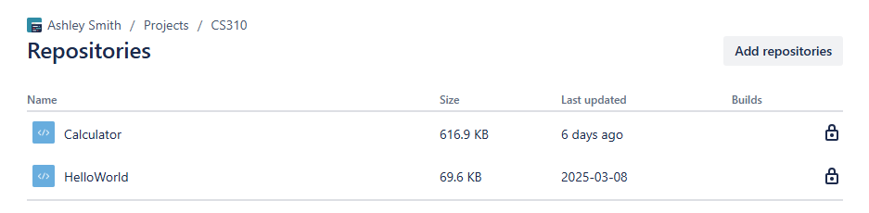

Bitbucket for calculator app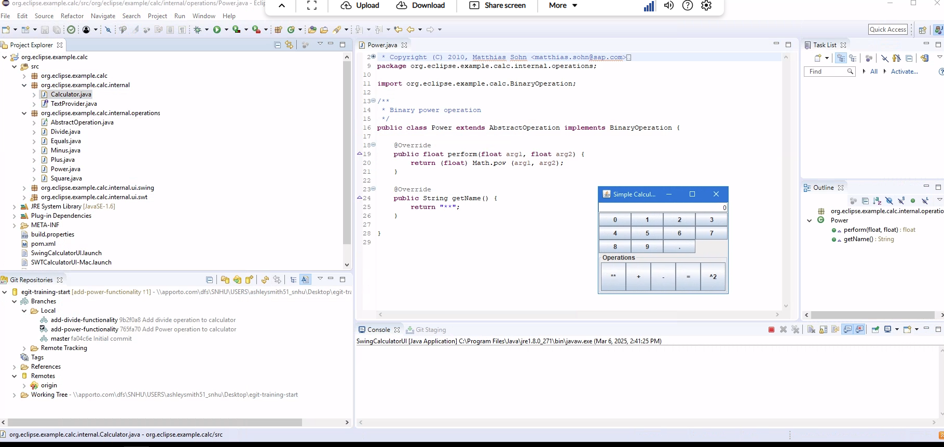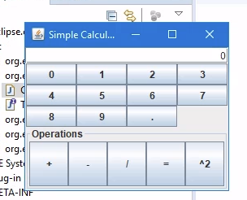

Working calculator application with power and division added

Group team project with team collaboration for Jukebox project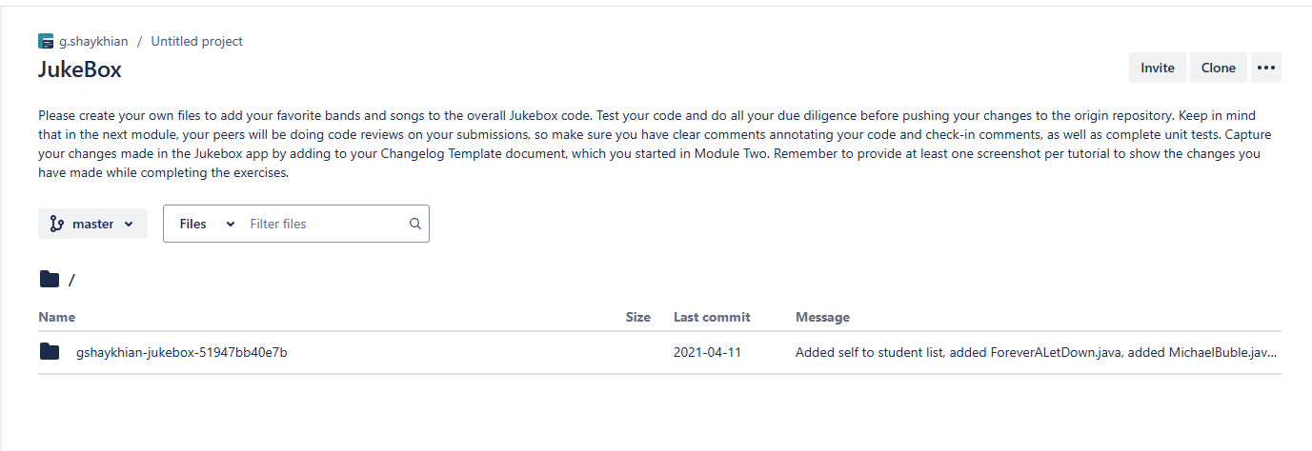

Added Ashley Smith playlist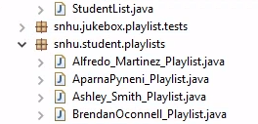

Added a profile for it to switch to Ashley Smith’s playlist

